Workshop #6: **Collection framework**

**Learning Outcomes:**

Upon successful completion of this workshop, you will have demonstrated the abilities to:

* Practice the ArrayList class.
* Practice some basic functions : add, update, remove, display, search,… in the list
* Describe to your instructor what you have learned in completing this workshop.

**Total:** [10 points]

In this demonstration, ArrayList is used to store a list of students. Student details include: Code, name, mark. A menu is supported for user choosing one operation at a time:

(1) Add new student

(2) Search a student based on his/her code

(3) Update name and mark of a student based on his/her code

(4) Remove a student based on his/her code

(5) List all students.

(6) Sort All Student by mark (descending) and display using Compable

(7) Sort All Student by mark (Ascending), if mark equals sort by Name and display using Comprator

Constraints:

Student code must be in format <S000>, 0 is a digit.

Student name can not be blank

Mark: 0..10

Design:

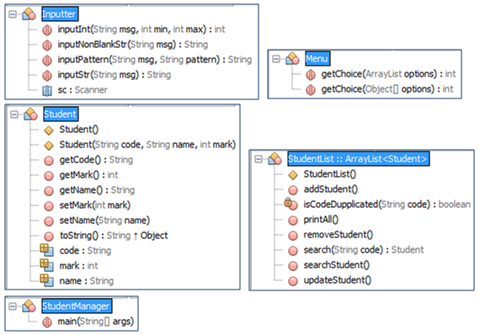

Implement:

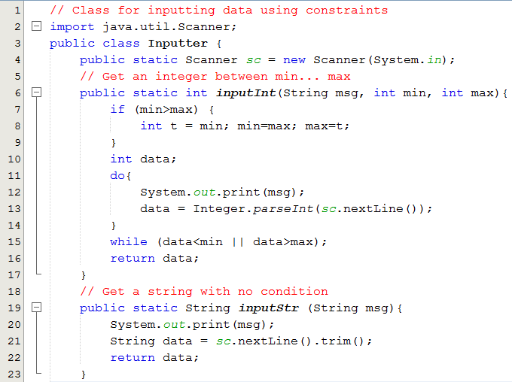

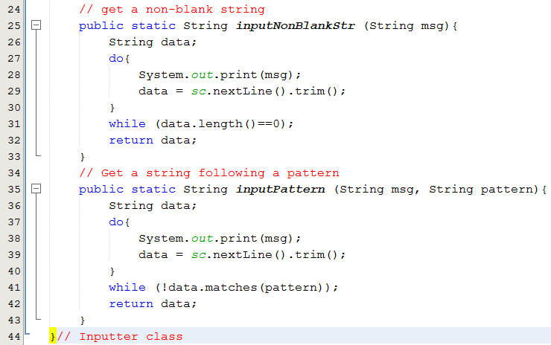

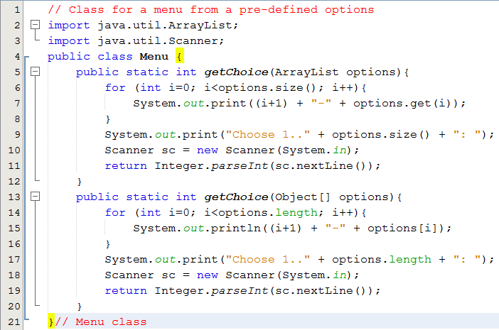

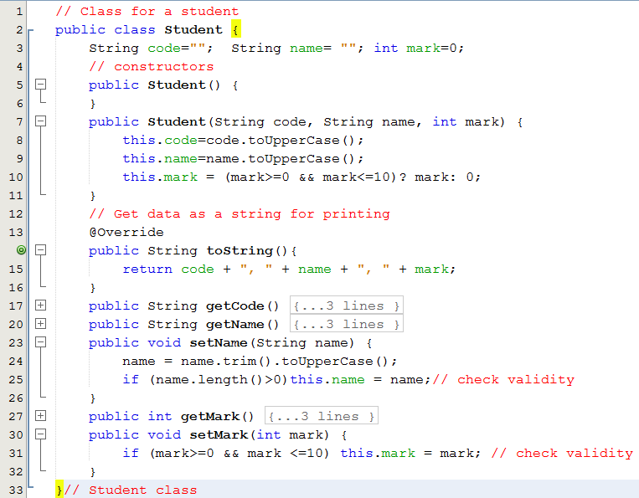

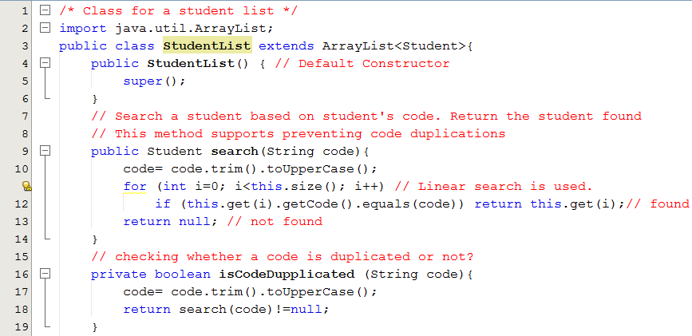

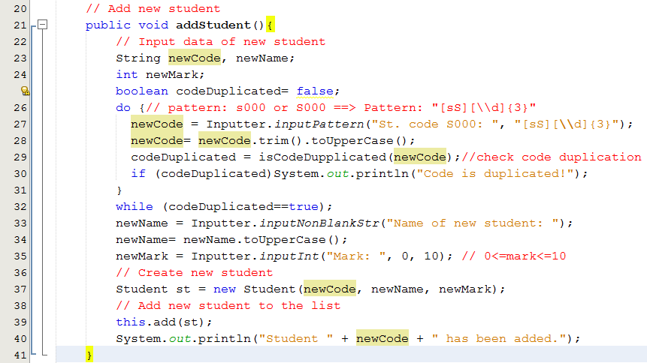

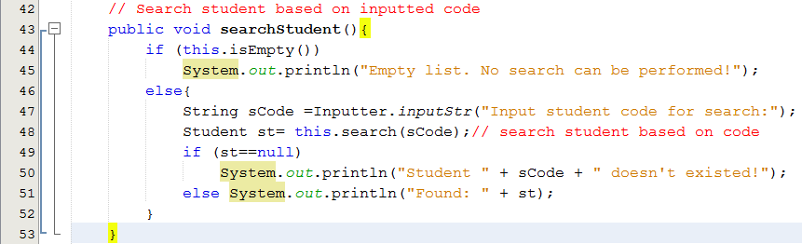

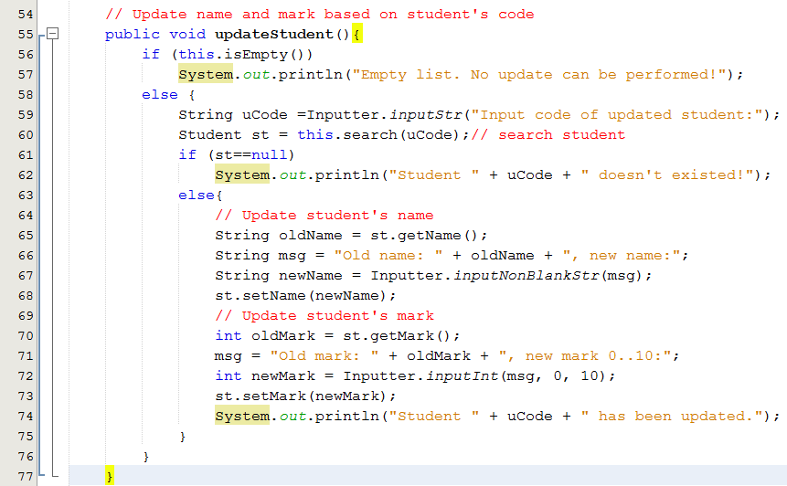

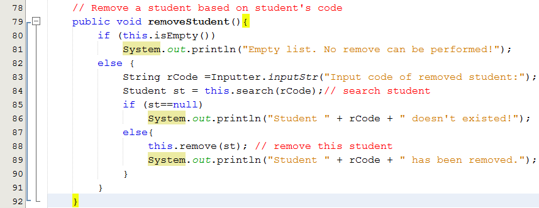

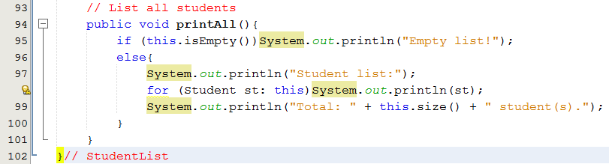

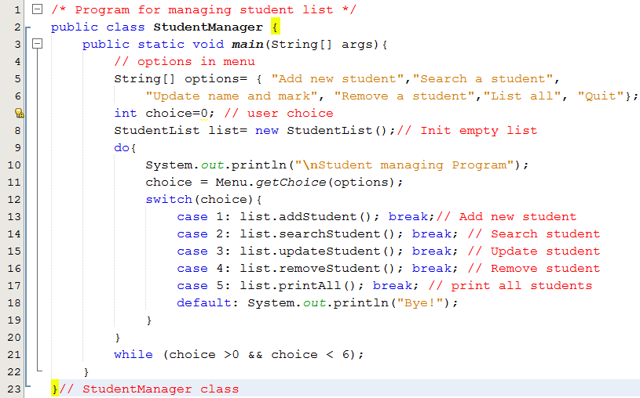

**Test cases**

Run the program, the following menu allows user to choose one operation at a time:

Student managing Program

1-Add new student

2-Search a student

3-Update name and mark

4-Remove a student

5-List all

6-Quit

Choose 1..6:

|  |  |  |
| --- | --- | --- |
| **Test case** | **Option** | **Input and Result** |
| 1 | 2 | No input,  Output: Message: Empty list. No search can be performed! |
| 2 | 3 | No input,  Output: Message: Empty list. No update can be performed! |
| 3 | 4 | No input.  Output: Message: Empty list. No remove can be performed! |
| 4 | 5 | No input.  Output: Message: Empty list! |
| 5 | 1 | Input code : ABC/ A1234/ S12345/S001.  Input name: blank/ James  Input mark: -2/12/7  Message: Student S001 has been added. |
| 6 | 2 | Add: S008, Jack, 5 |
| 7 | 3 | Add: s004,monica, 8 |
| 8 | 5 | Output:  Student list:  S001, JAMES, 7  S008, JACK, 5  S004, MONICA, 8  Total: 3 student(s). |
| 9 | 2 | Input student code for search: Input S123  Output: Student S123 doesn't exist! |
| 10 | 2 | Input student code for search: Input s008  Output: Found: S008, JACK, 5 |
| 11 | 3 | Input code of updated student: Input S123  Output: Student S123 doesn't exist! |
| 12 | 3 | Input code of updated student: Input s008  Old name: JACK, new name: input bill  Old mark: 5, new mark 0..10: input 10  Output: Student s008 has been updated. |
| 13 | 5 | Output:  Student list:  S001, JAMES, 7  S008, BILL, 10  S004, MONICA, 8  Total: 3 student(s). |
| 14 | 4 | Input code of removed student: Input s123  Output: Student s123 doesn't exist! |
| 15 | 4 | Input code of removed student: Input s008  Output: Student s008 has been removed. |
| 16 | 5 | Output:  Student list:  S001, JAMES, 7  S004, MONICA, 8  Total: 2 student(s). |